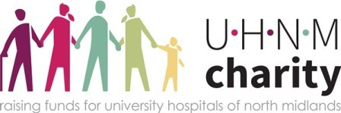

*UHNM Charity Registered Charity no.* 1054889